**Project Development**

**Sprint-3**

|  |  |
| --- | --- |
| **Team ID** | PNT2022TMID02439 |
| **Project Name** | Smart farmer-IOT enabled smart farming application |
| **Team Members** | Kamesh Kumar K , Kaviyaraj C , Javeed Akram Z , KavinSaran JK |

# **Step 1:** Login Into MIT App Inventor

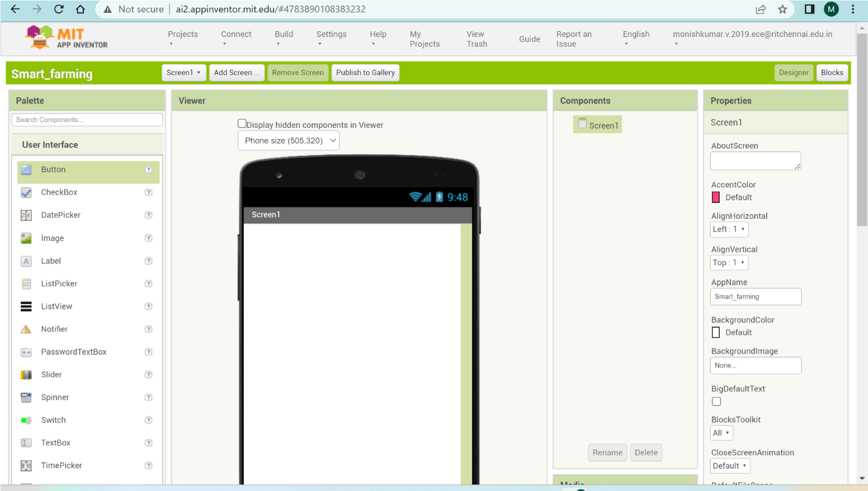

# **Step 2:** Create Your User Interface By Using the Preset Tools

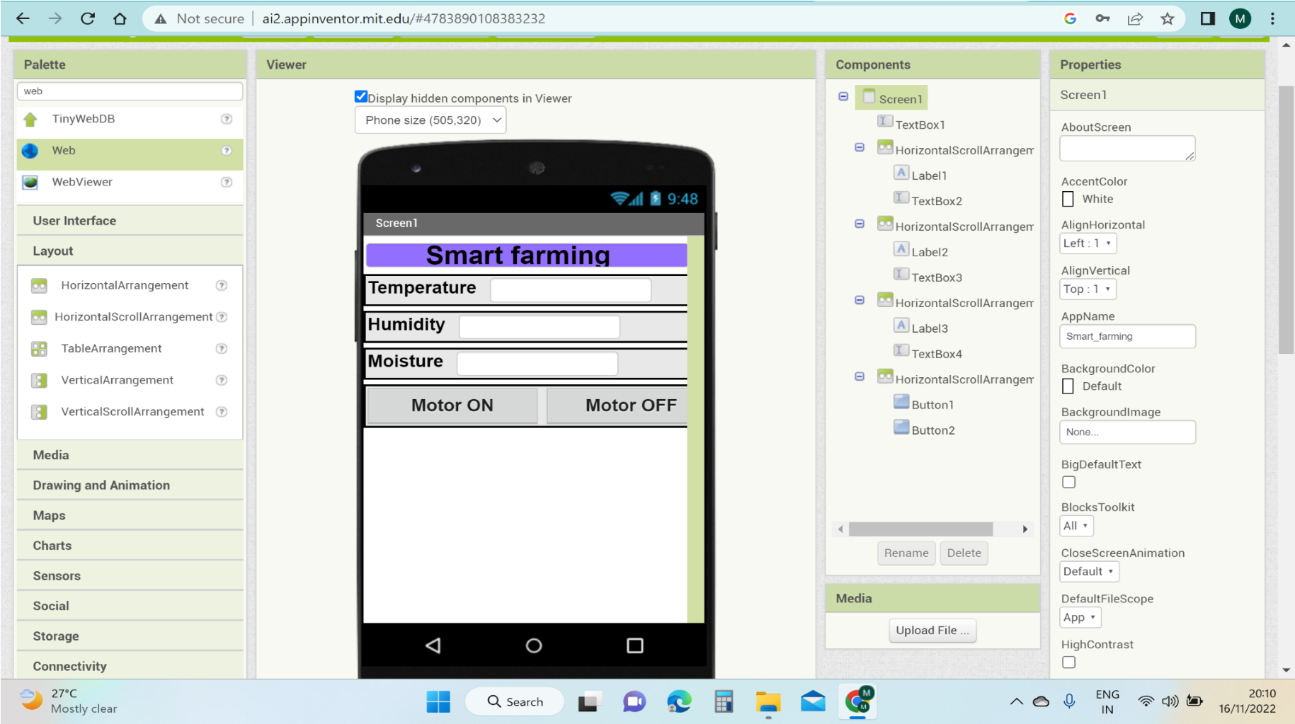

# **Step 3:** Back End Process

* Specify the Cloud URL Details to Receive the Date From Node Red.
* Commend Request From App To Node RED to Turn ON /OFF Motor.
* Weather API Data is Displaced From Node RED.

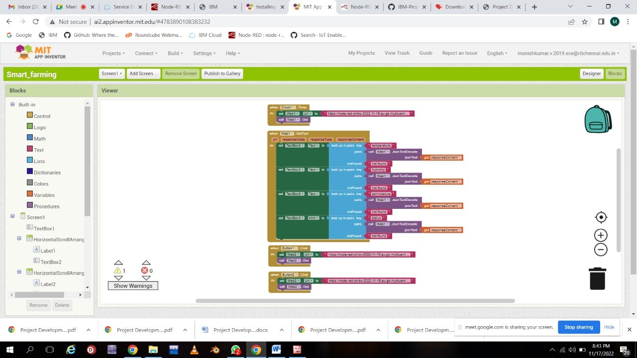

**Step 4:** Live Output In Mobile Application

